Mak Tsz To, Salome (21) J.1 Love 13th November, 2021

In the park
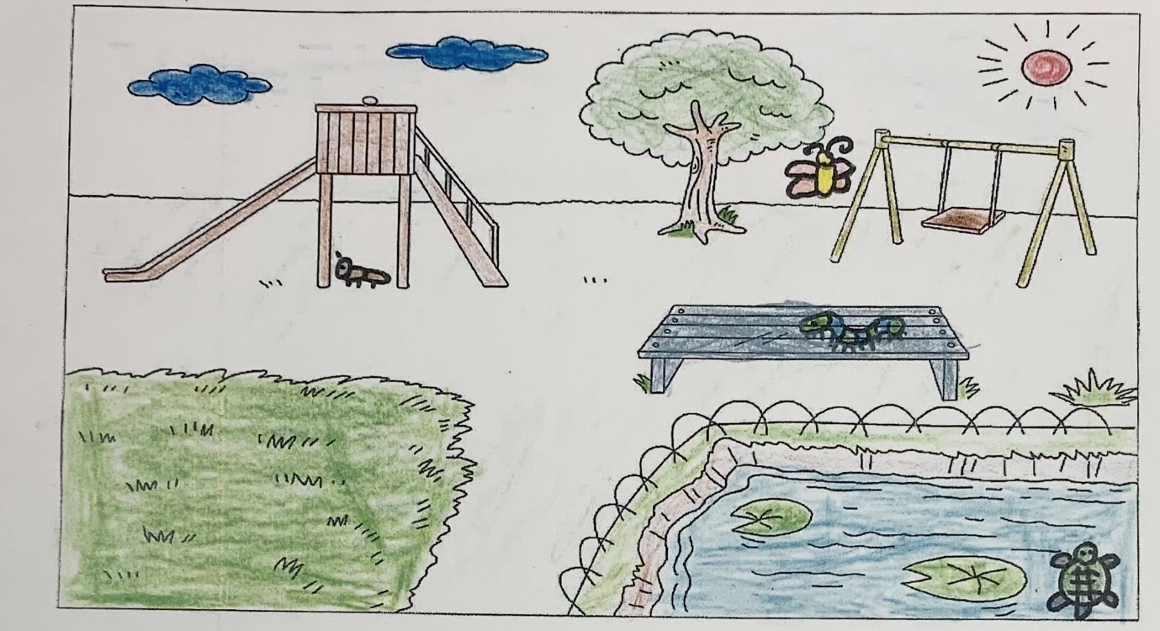

I can see a butterfly.
It is near the swing.
It is red and yellow.
I can see a caterpillar.
It is on the bench.
It is blue and green.
I can see an ant.
It is under the slide.
It is brown.
I can see a turtle.
It is in the pond.
It is green and black.

